**1. Use same formula to calculate sizeterms**

st.hbs = ret.emp + .008396 * non.ret + .022126*HHold,

st.hbr = tot.emp + 1.278 * HHold + 4.6833 *ParkAcres,

st.hbo = 0.2393 * HHold + ret.emp + 0.6419 * svc.emp + 0.6109 * gvt.emp + 0.06802 * non.retsvcgvt,

**2. use same cutoff as TCI at Portland**

hbwci <- identify_centers(TAZPloyNoNA, "totemp.den", 2500, dist=1.0, sum.col="tot.emp", sum.cutoff=1000)

hbwci <- hbwci %>% dplyr::select(TAZ, center.id=cluster.id) %>% arrange(TAZ)

# identify hbs tazs of centers

hbsci <- identify_centers(TAZPloyNoNA, "st.hbs.den", 102, dist=1.0, sum.col="st.hbs", sum.cutoff=1000)

hbsci <- hbsci %>% dplyr::select(TAZ, center.id=cluster.id) %>% arrange(TAZ)

# identify hbr tazs of centers

hbrci <- identify_centers(TAZPloyNoNA, "st.hbr.den", 1763, dist=1.0, sum.col="st.hbr", sum.cutoff=1000)

hbrci <- hbrci %>% dplyr::select(TAZ, center.id=cluster.id) %>% arrange(TAZ)

# identify hbo tazs of centers

hboci <- identify_centers(TAZPloyNoNA, "st.hbo.den", 495, dist=1.0, sum.col="st.hbo", sum.cutoff=1000)

hboci <- hboci %>% dplyr::select(TAZ, center.id=cluster.id) %>% arrange(TAZ)

**3. weighted.mean function does not work well**

**Original scripts:**

The weighted.mean function only get one value.

AggCost.Zi <- weighted.mean(TimeCostArray[, , cm], TotTripsArray)

**I change it to**

AggCost.Zi <- array(0, dim = c(length(Zi), 1), dimnames=list(Zi, "cost"))

for (zi in Zi) {

zi.char <- as.character(zi)

AggCost.Zi[zi.char,] <- weighted.mean(TimeCostArray[zi.char, , cm], TotTripsArray[zi.char,])

}

**New results are more reasonable**

**Original**

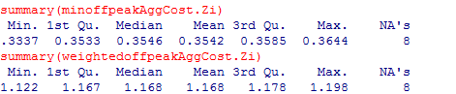

**New**

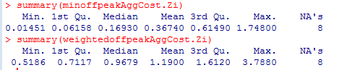

**I use stargazer to export the summary results:**

df.Zi <- data.frame(minoffpeakAggCost.Zi, minpeakAggCost.Zi,

weightedoffpeakAggCost.Zi, weightedpeakAggCost.Zi)

stargazer(df.Zi, type = "text", title="Descriptive statistics",

summary.stat = c("n","min", "p25", "median", "mean","sd", "p75", "max"),

digits=4,out="C:/Users/huajie/Desktop/table1.txt")

